Bank Account Management System
A Python Project Report

Student Name : SHIVRAM UPALE & TEERTHENDU DAS GUPTA
DIV/ Roll_No : SYA\39 & SYA\44
Course / Subject :CSE(AI/ML)/PYTHON PROGRAMMING

Problem Statement
Banks and financial applications must let a customer perform basic operations on an account safely: checking the balance, depositing money and withdrawing money. Mistakes such as withdrawing more than the available balance, entering negative amounts, or typing non-numeric input can corrupt an account or crash a program.
This project builds a simple console-based Bank Account Management System in Python that performs these operations while validating every input and giving clear feedback to the user.

Objectives
- To design a BankAccount class that models a real-world bank account using object-oriented programming.
- To implement deposit, withdrawal and balance-check operations.
- To validate user input (positive amounts, sufficient funds, numeric values).
- To handle special cases such as an empty account (balance of $0.00).
- To provide a menu-driven interface that runs until the user chooses to exit.
- To practise exception handling, loops and conditional logic in Python.

Methodology
The program was developed in the following steps:
- Analysis: Identified the data (account holder name, balance) and the operations (deposit, withdraw, check balance).
- Design: Created a BankAccount class with a constructor and three methods, and a main() function for the menu.
- Implementation: Wrote the class and the menu loop, adding validation checks in every method.
- Error handling: Wrapped numeric input in try/except blocks so invalid text does not crash the program.
- Testing: Ran the program in VS Code with deposits, withdrawals, balance checks, an overdraft attempt and the exit option.

Program Flow
- The user enters the account holder's name; an account is created with a $0.00 balance.
- A menu is shown: Check Balance, Deposit Money, Withdraw Money, Exit.
- The user picks an option; the matching method runs and prints the result.
- The menu repeats until the user selects option 4.

Python Concepts Used
Concept | Where it is used
Classes and objects | BankAccount class and the account object
Constructor (__init__) | Initialises the account holder and balance
Instance variables | self.account_holder, self.balance
Methods | deposit(), withdraw(), check_balance()
Functions | main() controls the program
Conditional statements | if / elif / else for validation and menu choice
Loops | while True keeps the menu running
Exception handling | try / except ValueError for invalid numbers
Type conversion | float(input(...)) converts text to a number
String formatting | f-strings such as {amount:.2f} for currency
Default arguments | initial_balance=0.0
Input / Output | input() and print()
Entry point check | if __name__ == "__main__":

Source Code

class BankAccount: def __init__(self, account_holder, initial_balance=0.0):
self.account_holder = account_holder self.balance = initial_balance
def deposit(self, amount): if amount > 0:
self.balance += amount
print(f"Successfully deposited ${amount:.2f}. New Balance: ${self.balance:.2f}") else: print(" Deposit amount must be greater than zero.")
def withdraw(self, amount): # Check if the account is completely empty if self.balance == 0.0:
print("⚠ Your account is currently empty! You cannot withdraw money.") return
if amount > 0: if amount <= self.balance: self.balance -= amount
print(f"Successfully withdrew ${amount:.2f}. Remaining Balance: ${self.balance:.2f}")

# Check if the account just became empty after withdrawal if self.balance == 0.0:
print("⚠ Note: Your account is now empty ($0.00).") else:
print(f" Insufficient funds! You only have ${self.balance:.2f} in your account.") else: print(" Withdrawal amount must be greater than zero.")
def check_balance(self): if self.balance == 0.0:
print("⚠ Your account is currently empty ($0.00).") else:
print(f" Current Account Balance: ${self.balance:.2f}")

def main():
print("=========================================") print(" WELCOME TO THE BANK SYSTEM ") print("=========================================")

name = input("Enter the account holder's name: ")
# Starting with an empty account by default account = BankAccount(name, initial_balance=0.0)
print(f"\nAccount created for {name} with an initial balance of $0.00.")
while True:
print("\n--- MENU ---") print("1. Check Balance") print("2. Deposit Money") print("3. Withdraw Money") print("4. Exit")

choice = input("Enter your choice (1-4): ")
if choice == '1':
account.check_balance() elif choice == '2': try:
amount = float(input("Enter amount to deposit: $")) account.deposit(amount) except ValueError:
print(" Invalid input! Please enter a valid number.") elif choice == '3': try:
amount = float(input("Enter amount to withdraw: $")) account.withdraw(amount) except ValueError:
print(" Invalid input! Please enter a valid number.") elif choice == '4':
print("Thank you for using the banking system. Goodbye!") break else: print(" Invalid choice! Please select an option between 1 and 4.")
if __name__ == "__main__":
main()

Output Screenshots
The program was run in the VS Code terminal. The screenshots below show the output for a sample account holder.

Account creation, deposit, withdrawal and balance check
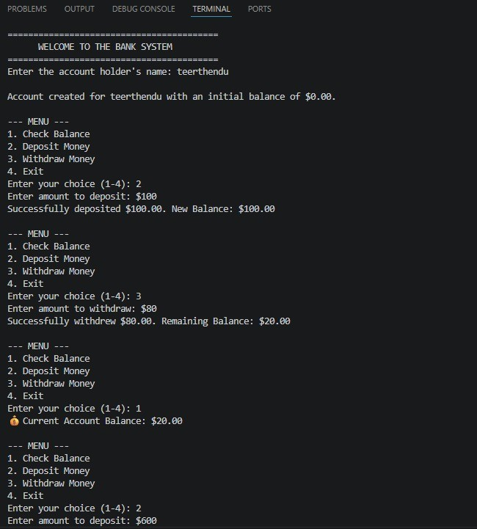
Explanation: The welcome banner appears and an account is created with an initial balance of $0.00. Depositing $100 updates the balance to $100.00, withdrawing $80 leaves $20.00, and option 1 confirms the current balance.

Further deposit, insufficient funds and exit
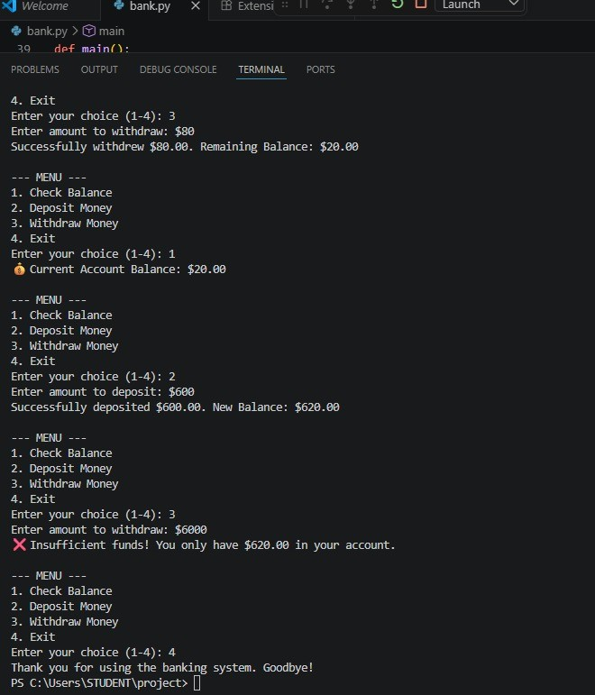
Explanation: After depositing $600 the balance becomes $620.00. Trying to withdraw $6000 is rejected with an insufficient-funds message and the balance is unchanged.
Choosing option 4 prints a goodbye message and ends the program.

Conclusion
The Bank Account Management System meets its objectives. It uses a BankAccount class to keep the data and the operations together, and a menu-driven main() function to let the user interact with the account repeatedly. Input validation, try/except handling and special messages for an empty account make the program robust against common mistakes such as overdrafts, negative amounts and non-numeric input. The output screenshots confirm that deposits, withdrawals, balance checks, the insufficient-funds check and the exit option all work correctly.
Through this project I practised object-oriented programming, conditional logic, loops, exception handling and formatted output in Python.

